|  |
| --- |
| Test conducted |February 2021 |

NATIONAL COMMUNICATIONS AUTHORITY

**QUALITY OF 4G DATA SERVICES REPORT- MTN**

**GREATER ACCRA REGION**



CONTENTS

1 EXECUTIVE SUMMARY 3

1.1 GENERAL FRAMEWORK 3

1.2 TEST/MEASUREMENT AND POST-PROCESSING SYSTEMS 3

1.3 MEASUREMENT PROFILE 4

1.3.1 MEASUREMENT SEQUENCE 4

2 PARAMETERS, DEFINITIONS AND FORMULAE 6

3 FINDINGS AND ANALYSIS 8

3.1 TEST LOCATIONS AND TIMES 8

3.2 SUMMARY RESULTS 8

3.2.0 KPIs 8

3.2.1 GRAPHS 9

4 CONCLUSION 10

TABLE OF FIGURES

Figure 1. Sample Test Script 5

Figure 3. Data Throughput Graph 9

Table 1. Ping Test Profile 4

Table 2. HTTP Get Test Profile 4

Table 3. FTP Get Test Profile 4

Table 4. Network Connect Profile 4

Table 5. Details of Test Locations in Greater Accra Region 8

Table 6. MTN performance (in counts) with respect to QoS licence conditions in Greater Accra Region. 9

# EXECUTIVE SUMMARY

## GENERAL FRAMEWORK

From the 11th February to the 1st March 2021, the National Communications Authority (NCA) carried out an assessment of 4G mobile data services provided by MTN in the Greater Accra Region by analysing technical parameters that translate into the perception of quality from the user’s standpoint.

The methodology that was used in this study relies on field tests performed from the user’s standpoint, by using NEMO INVEX II for data collection and NEMO WINDCATCHER for analysis and reporting. The automatic measurement system measures several parameters that reflect the quality of data services (end-to-end measurements). Measurements were carried out on equal terms regarding the three operators at the same time, the same locations and with the same parameters, thus making it possible to perform comparative analysis of the observed performances.

The main quality indicators analysed, considering the user’s perspective and the services under study are as below:

**Data Service Access Time** - time it takes for standard web page to start loading.

**Latency** - the amount of time it takes to transmit data between source and destination.

**Data Throughput** - the speed at which information is accessed.

The technical and methodological options of this study directly influenced its results and must be taken into account when analysing the results, namely the following ones:

* Tests were exclusively based on a technical solution (equipment + software) and performed in a totally automatic way, thereby setting homogenous conditions for the monitoring of the operators and eliminating the subjectivity inherent to the human operator of the system.
* Tests were carried out in stationary vehicles.
* Data tests were made with the handset locked to 4G LTE Technology.
* The results of the study only reflect the behaviour of the networks on the locations and moments of the measurements.

## TEST/MEASUREMENT AND POST-PROCESSING SYSTEMS

The *NEMO OUTDOOR* system was used for measurements on the field and *NEMO WINDCATCHER* was used for the post-processing.

This system which is specifically designed for the analysis and benchmarking of cellular mobile communications systems is made up of the following modules:

1. Mobile User Equipment (NEMO INVEX II) equipped with 4G-capable ***Samsung Galaxy Note 5*** and external GPS.
2. QoS analysis and reporting (NEMO WINDCATCHER) equipped with software licences for Table and mapping analysis and also for reporting in excel.
3. Test is conducted with the device locked to 4G.

## MEASUREMENT PROFILE

Measurement profiles define a set of conditions that must be verified in order to correctly assess the quality of service and to guarantee the reliability of the tests. They also include process standardization and the definition of testing and measurement parameters, thus making it possible to perform analyses and compare results.

### MEASUREMENT SEQUENCE

The measurement sequence of this test is controlled by a script. The sequence of activities starts with the configuration activities. This includes a network connect activity where the particular network’s details such as the APN and IP Address etc. are set and the setting of the Radio Access Technology ‘Locked’ to 4G. A five second wait period ends the configuration activities and allows the system to fully apply the selected settings.

The next set of activities referred to as the measurement sequence activities is where the actual testing takes place. A Ping Test is done, followed by HTTP Download Test and an FTP download Test in that order and separated by five (5) seconds wait time. The test ends with the Network Disconnect Activity and is iterated continuously throughout the test duration. Details of the various tests are listed below:

Table 1. Ping Test Profile

|  |  |
| --- | --- |
| **PING TEST** | |
| Remote Address | 192.201.2.2 |
| Ping size | 32kb |

Table 2. HTTP Get Test Profile

|  |  |
| --- | --- |
| **HTTP TEST** | |
| URL | http://google.com |
| Use Proxy Server | False |
| End Session after Time | False |
| End Session After Payload | False |

Table 3. FTP Get Test Profile

|  |  |
| --- | --- |
| **FTP TEST** | |
| Direction | Download |
| Server Address | 57.178.136.189 |
| Username | qosftpsite@nca.org.gh |
| File Size | 20MB |
| Server Port | 21 |
| Remote file | QOS_4G.txt |

Table 4. Network Connect Profile

|  |  |
| --- | --- |
| **NETWORK CONNECT TEST** | |
| APN | Internet |
| IP Address | Null |
| Username | Null |
| Succeed if already connected | True |

Figure 1. Sample Test Script

Below is a sample of the test script: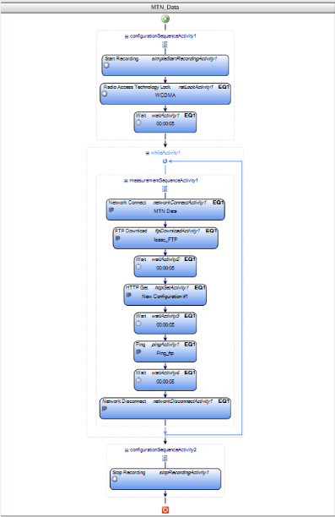

# PARAMETERS, DEFINITIONS AND FORMULAE

This report is on the assessment of quality of cellular mobile data services provided by the MTN in the Greater Accra Region. As per the 4G Cellular Mobile licence obligations, the QoS indicators and their respective threshold for compliance under assessment considering the user’s perspective are;

Fig. 1: Data Session (eg. HTTP via LTE network)

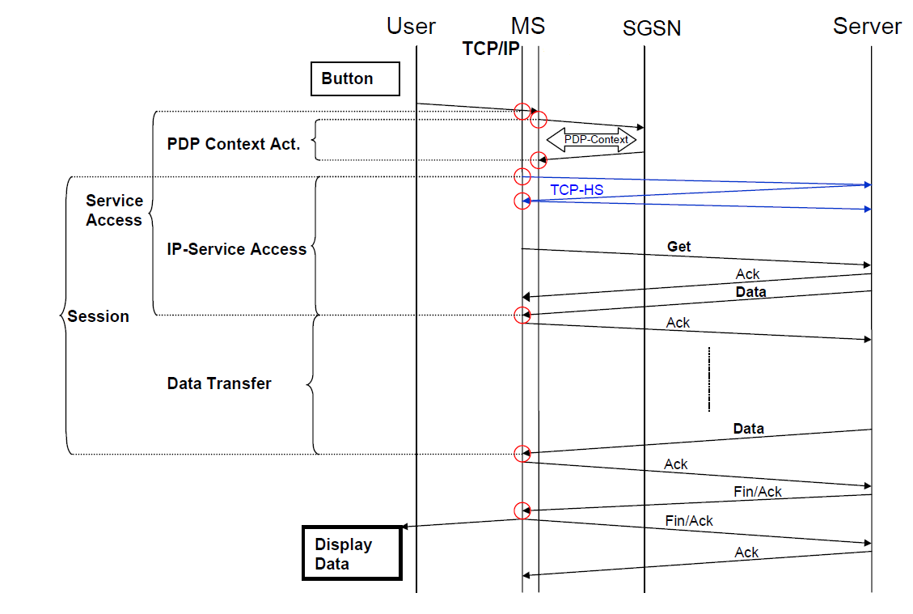

1. **Data Service Access Time**

Data Service Access Time should be equal or less than ***five seconds (5 sec)*** for 95th percentile of samples***.***

Date Access Success Rate is the time it takes for a web page to start loading. That is, from when user enters URL and hits ‘return’ to when the web page download starts.



- Moment when the first data packet containing content is received

– Moment user presses the ‘return’ after entering the URL

1. **Latency**

Latency should be equal or less than ***eighty milli seconds (80 msec).***

It measures the amount of time it takes to transmit data between source and destination. Latency will be calculated from the Round Trip Time obtained from the ping tests.

1. **Data Throughput**

Throughput is the rate of data transfer.

As per the 4G licence obligations, the average data transfer rate should be greater than or equal to ***5Mbps*** for all sessions.

Data Throughput values were obtained from the FTP sessions

# FINDINGS AND ANALYSIS

## TEST LOCATIONS AND TIMES

The Quality of Cellular Data Service monitoring was conducted in the Greater Accra Region from the 11th February to 1st March, 2021. The tests were carried out at locations chosen to give an accurate representation of network performance at economic, educational and residential hotspots during peak times. Table 6 below indicates the locations and times of the testing.

|  |  |  |  |
| --- | --- | --- | --- |
| DATE | TIME | LOCATION | DISTRICT |
| 11/02/2016 | **1:39pm-4:37pm** | Central University | Ningo-Prampram |
| 15/02/2016 | **4:19pm-5:20pm** | Ashaiman Station | Ashaiman |
| 18/02/2016 | **11:30am-12: 40pm** | Ada Foah Lorry Station | Dangme East |
| 18/02/2016 | **3:36pm-4:30pm** | Sege Community Cooperative Union | Ada West |
| 19/02/2016 | **8:32am-9:37am** | Kpone Lorry Station | Kpone |
| 19/02/2016 | **10:15am-11:16am** | Tema Casino / TMA | Tema Metropolitan |
| 22/02/2016 | **4:13pm-5:13pm** | Junction Mall | Ledzokuku-Krowor |
| 22/02/2016 | **5:30pm-6:30pm** | Regional Maritime University |
| 22/02/2016 | **7:12pm-8:30pm** | Osu (Oxford Street) | Accra Metropolitan |
| 01/03/2016 | **11:15am-12:15pm** | Accra Poly |
| 01/03/2016 | **12:40pm-1:40pm** | AMA |
| 25/02/2016 | **7:15pm-8:25pm** | University of Ghana | La-Nkwantanang-Madina |
| 29/02/2016 | **2:10pm-3:10pm** | Madina Zongo Junction |
| 01/03/2016 | **5:40pm-7:00pm** | University of Professional Studies |
| 26/02/2016 | **1:10pm-2:10pm** | West Hills Mall | Ga South |
| 26/02/2016 | **5:55pm-6:55pm** | Pantang General Hospital | Ga East |
| 26/02/2016 | **8:00pm-9:00pm** | Adenta SSNIT Flats | Adenta |
| 29/02/2016 | **12:00pm-1:00pm** | Valley View University | Dangme West |
| 29/02/2016 | **7:25pm-8:25pm** | Pentecost University | Ga Central |
| 29/02/2016 | **5:40pm-6:40pm** | Agya Appiah Distilleries | Ga West |
| 01/03/2016 | **7:35pm-8:35pm** | Kingsby Roundabout |

Table 5. Details of Test Locations in Greater Accra Region

## SUMMARY RESULTS

### KPIs

The findings of the study only reflect the behaviour of the networks at the locations and on the period of the measurements.

By analyzing the technical parameters that translate into the quality perception from the mobile phone user’s standpoint and benchmarking against compliance requirements as per the 4G licence, the summary of the results of the three QoS parameters under consideration are as in Table 6 below:

Table 6. MTN performance (in counts) with respect to QoS licence conditions in Greater Accra Region.

|  |  |  |  |
| --- | --- | --- | --- |
| **District Capital** | **Data Service Access Time (sec)**  ≤ 5sec | **Data Latency (msec)**  ≤ 80ms | **Data Throughput (Mbps)**  ≥ 5 Mbps |
| [Abokobi](https://sites.google.com/site/ghanaplacenames/database/greater-accra/abokobi) | 4.11 | 70 | 6.521 |
| [Accra](https://sites.google.com/site/ghanaplacenames/database/greater-accra/accra) | 5.32 | 120 | 4.234 |
| Adenta | 2.35 |  |  |
| [Amasaman](https://sites.google.com/site/ghanaplacenames/database/greater-accra/amasaman) |  |  |  |
| [Ashaiman](https://sites.google.com/site/ghanaplacenames/database/greater-accra/ashaiman) |  |  |  |
| [Dodowa](https://sites.google.com/site/ghanaplacenames/database/greater-accra/dodowa) |  |  |  |
| [Kpone](https://sites.google.com/site/ghanaplacenames/database/greater-accra/kpone) |  |  |  |
| [Madina](https://sites.google.com/site/ghanaplacenames/database/greater-accra/madina) |  |  |  |
| Prampram |  |  |  |
| [Sowotuom](https://sites.google.com/site/ghanaplacenames/database/greater-accra/sowotuom) |  |  |  |
| [Tema](https://sites.google.com/site/ghanaplacenames/database/greater-accra/tema) |  |  |  |
| [Teshie-Nungua](https://sites.google.com/site/ghanaplacenames/database/greater-accra/teshie-nungua) |  |  |  |

### GRAPHS

The graphical presentation of Data Throughput in the localities are as in the figures below:

Figure 3. Data Throughput Graph

**Remarks:** MTN failed to meet the Throughput licence condition at TMA and Kpone Lorry Station.

# CONCLUSION

* MTN failed its Licence obligation for Data Access Time, Latency and Data Throughput at Kpone and Tema.
* MTN needs to improve Data Throughput levels at TMA and around the Kpone Lorry Station.